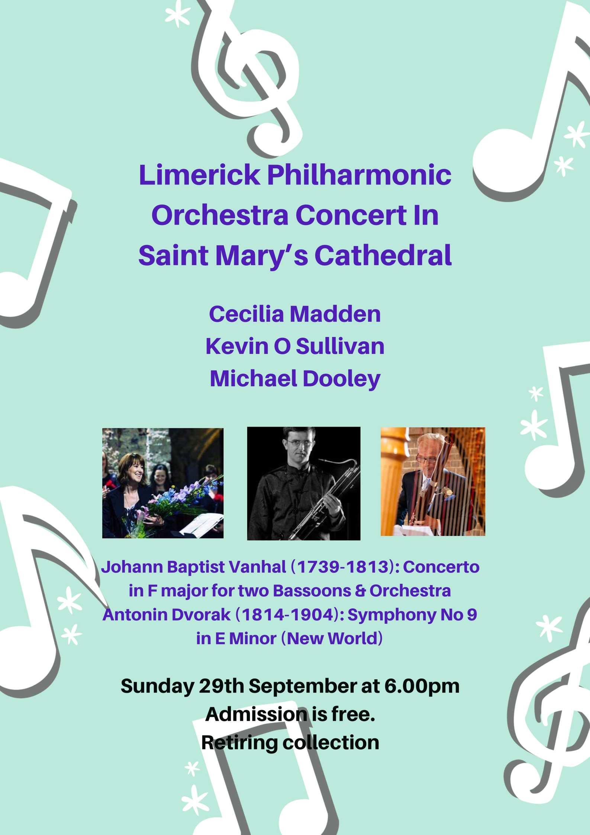
Programme

Johann Baptist Vanhal Concerto in F Major for 2 Bassoons
Antonin Dvorak Symphony No 9 in E Minor (New World)

Conductors

Michael Dooley
Cecilia Madden

Soloists

Michael Dooley
Kevin O’ Sullivan

Concerto in F major for two Bassoons and Orchestra

Johann Baptist Wanhal (1739-1813)
The Bohemian musician Jan (Johann) Vaňhal, who lived and worked in Vienna, may be regarded as one of the most prolific composers of his time: he wrote over one thousand three hundred works including some sixty concerti for various instruments. The bassoon, in the 18th century, appeared relatively rarely as a solo instrument, which makes Vaňhal’s decision to compose a concerto even more interesting, especially as the main role is given to two bassoons. The concerto is in the usual three movements couched in the Viennese style. The first Movement is an allegro moderato where both players imitate and converse with each other across the range of the instrument with the various themes whilst playing in flowing thirds and sixths. The Andante Grazioso is a beautiful moment in triple time which is somewhat reminiscent of Mozart's requiem. The finale of the concerto, traditionally written in a quick tempo, affords the soloists the opportunity to compete in terms of virtuoso skill not just with the orchestra but with each other.
Symphony No 9 in E Minor (New World)
Antonin Dvorak (1841 – 1904)
The opening movement begins with an Adagio introduction, which gradually speeds and resolves into the main body of the movement (Allegro molto). Dvorák immediately announces the main theme, a distinctive motto that will appear, in one form or another, in every movement of the symphony. This bold E minor theme is first played by the horns, and then expanded by the strings. He introduces two contrasting melodies, a dancelike minor-key melody in, introduced by the oboe, and somewhat brighter theme heard in the solo flute. This sonata-form movement features a lengthy development section, which focuses on the motto theme. After a conventional recapitulation, Dvorák sets a long coda, which again explores the motto theme.

According to Dvorák, the second and third movements were inspired by Longfellow’s Song of Hiawatha. In the Largo we have Hiawatha’s “Funeral in the Forest.” This movement is set in a broad three-part form. It opens with a solemn brass chorale, which leads into the movement’s main theme, a long Romantic melody played by the Cor Anglais. (This melody became popular as nostalgic song called Goin’ Home—so popular, in fact, that it was widely assumed that it was a traditional spiritual that Dvorák had quoted!) The contrasting middle section features a more pensive melody heard first in the flute. The movement ends with a return of the Cor Anglais melody.

Dvorák again referred to Hiawatha in the Scherzo (Molto vivace), stating that this movement was supposed to depict “…a feast in the wood, where the Indians dance.” The first section features two main themes, an offbeat melody introduced by solo woodwinds and a more lyrical melody played by the woodwinds as a section. Echoes of the motto theme lead gradually into a central trio. The trio section is certain dancelike, but its waltz-style themes seem to have a lot more to do with a Viennese ballroom than a Native American dance. The opening section returns, and Dvorák closes the movement with more reminiscences of the motto theme.

Antonin Dvorak (1841 – 1904) continued

The finale (Allegro con fuoco) begins with a few stormy introductory measures, and then Dvorák brings in the main theme in the brass. After this powerful theme, there is a more lyrical melody in the solo clarinet. Dvorák set the finale in sonata form, but he used the lengthy development not only to work with this movement’s themes, but also to develop music from previous movements. In particular, we hear versions of the motto and a faster reading of the Largo’s main theme. After recapitulating the fourth movement’s main themes, Dvorák launches into a huge coda, which again brings back material from previous movements.

Limerick Philharmonic Orchestra
1st Violins:  Anna-Jane Ryan (Leader)  Willie McElliogtt  Conor Molony  Yuki Nishioka  Hughie Connolly  Aditya Mukherji  Cathal Daly  Ciaran Collins  Archie Connolly  Valerie Gunning  2nd Violin:  Barry Shanahan  Breifne Considine  Karen Franklin  Isabella Watanabe  Laura Hynes  Lucia Murphy  Oscar Owens  Finola Molony  Cora Houlihan  Eileen Cleary  Violas:  Bryonie Hopper  Katarina Baker  Michelle O Connor  James Ó Coileáin  Tara Lee  Cellos:  Adrian Ivicevic  Deirdre Cussen  Anne Mannion  Zoe Stedje  Sarah Fitzgerald  Grainne Higgins  Jenny Holmes  Geraldine Dennehy  Timpani:  Hugh Clery Ward  Tuba:  Declan Hickey | Bassoons:  Kevin O Sullivan  Pia Roycroft  Oboes:  Pat Murray  Linda Patton  Cor Anglais:  Coral O Sullivan  Flutes:  Oisin McGill  Maria O Brien  Horns:  Cathy Redsell  Steve Crowley  Jonathan Luxton  Pat Jones  Trumpets:  Sharon Brooks  Heather Nash  Trombones:  Martin Mannion  Gareth Cox  Dermot O Gormon  Percussion:  Andrew Jordan  Clarinets:  David Cantillon  Barbara Dowling  Double Bass:  Rory Murphy  Michael Murphy  Teresa Turner  Tammy Plowman  Jacob Butler  Susie King Butler

