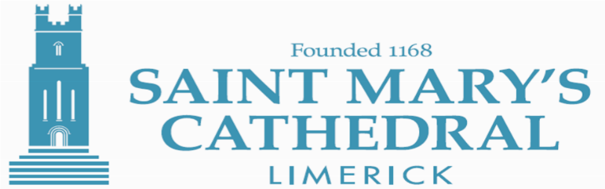

INVITATION

2018 is turning out to be a memorable and exciting year in the life of the cathedral choir at St Mary’s. Several major musical and liturgical celebrations are planned for this year, the 850th anniversary, so now is a really good time to consider coming forward to join the choir.

The cathedral choir has just recently performed Haydn’s wonderful mass setting Paukenmesse with full orchestra and soloists (on April 21st last). We are now looking forward to our next choral concert on Saturday May 19th, when our choir joins with the cathedral choirs of Kilkenny and Waterford for a special celebratory choral concert, including Mozart’s tuneful Coronation Mass.

Whilst St Mary’s Cathedral is a church in the full tradition of the Church of Ireland, membership of that church is not a pre-requisite for joining the cathedral choir.

If you love singing, church/choral music and historic buildings, then why not get in touch with us? We’d be pleased to hear from you. You don’t need to be an expert singer. What we are looking for are young people with a pleasant singing voice, able to sing in tune with an interest in, and commitment to, this kind of music-making within the context of this magnificent medieval cathedral.

We are particularly keen to encourage First and Second Year students and past experience has shown that post Junior Certificate (in particular transition year students) would benefit from joining.

Potential choir members and for further information should contact (details below) the Organist and Choirmaster, Mr. Peter Barley, to arrange an informal meeting at the cathedral.

______________________________________________________________________________________P: Bridge Street, Limerick, V94 E068, Ireland P: + 353 (0) 61 310 293 E: cathedral@limerick.anglican.org www.cathedral.limerick.anglican.org Dean: The Very Rev’d Niall J. Sloane

